**PIZZA SALES SQL SQUERIES**

KPI – (KEY PERFORMANCE INDICATORS)

1. TOTAL REVENUE

SELECT SUM(total_price) AS Total_Revenue FROM pizza_sales;

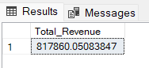

1. AVERAGE ORDER VALUE

SELECT (SUM(total_price) / COUNT(DISTINCT order_id)) AS Avg_order_Value FROM pizza_sales;

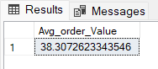

1. TOTAL PIZZA SOLD

SELECT SUM(quantity) AS Total_pizza_sold FROM pizza_sales;

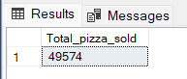

1. TOTAL ORDER

SELECT COUNT(DISTINCT order_id) AS Total_Orders FROM pizza_sales;

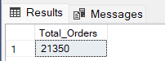

1. AVERAGE PIZZA PER ORDER

SELECT CAST(CAST(SUM(quantity) AS DECIMAL(10,2)) /

CAST(COUNT(DISTINCT order_id) AS DECIMAL(10,2)) AS DECIMAL(10,2))

AS Avg_Pizzas_per_order

FROM pizza_sales

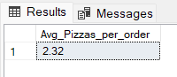

DAILY TREND FOR TOTAL ORDERS

SELECT DATENAME(DW, order_date) AS order_day, COUNT(DISTINCT order_id) AS total_orders

FROM pizza_sales

GROUP BY DATENAME(DW, order_date)

***RESULT:***

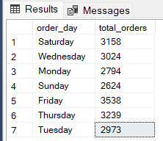

MONTHLY TREND FOR ORDERS

SELECT DATENAME(MONTH, order_date) AS Month_Name, COUNT(DISTINCT order_id) AS Total_Orders

FROM pizza_sales

GROUP BY DATENAME(MONTH, order_date)